Chethan Singh M J

CMU-Heinz College | Pittsburgh-pa

US counties at risk for a pandemic

GIS – Assignment 1

**Data:**

Data contains demographic details at the county level. Demographic details include various age groups, ethnicity, gender, housing stats, etc. Out of these details, risk analysis for a pandemic like COVID-19 requires below numbers:

1. Elderly population over age 65
2. Population density
3. Number of housing units

**Observations:**

1. New York city’s two of the five boroughs – Kings County (Brooklyn) and Queens County not only are among the top 5 counties with the highest population density but also among the top 10 counties for the elderly population. No wonder in this pandemic of COVID-19, we are witnessing the highest infections and deaths in New York City.
2. From the map of top counties for population density (figure 1), it can be inferred that New York City and Philadelphia City are USA’s densely populated cities. Though Philadelphia County is not among top counties for elderly population, much higher infection rates is being recorded in current pandemic compared to LA county which is the top county for elderly population. This may suggest that population density is a higher risk factor compared to elderly population count.
3. It looks like there is a direct correlation between the elderly population count and the number of housing units. Because 8 of the top 10 counties for the elderly population are also among the top 10 counties for the highest number of housing units.

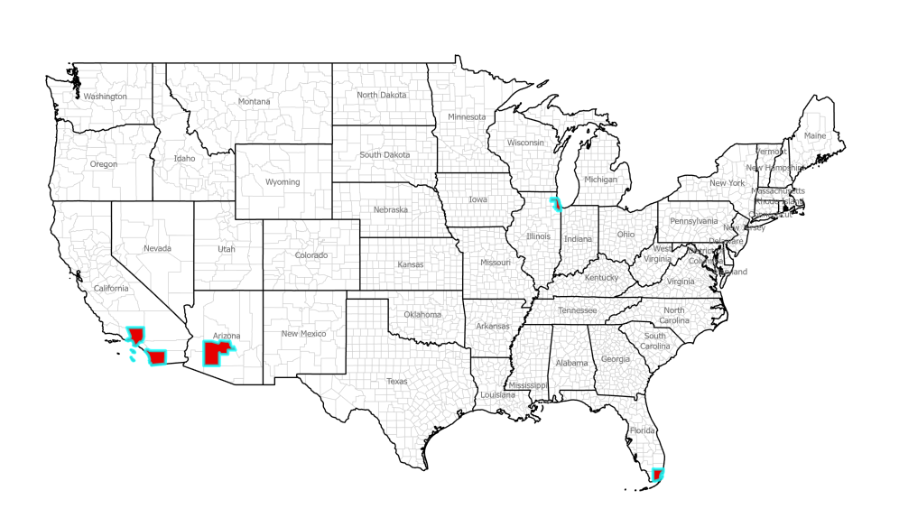

* 1. **Figure 1: US Counties with highest elderly population (US Census 2010)**

|  |  |  |  |  |  |  |  |
| --- | --- | --- | --- | --- | --- | --- | --- |
| |  |  |  |  | | --- | --- | --- | --- | | County and State |  |  |  | | Elderly Population Over Age 65 | Persons Per Square Mile | Number of Housing Units |
| Los Angeles County, California | 1,065,699 | 2,070.0 | 3,445,076 |
| Cook County, Illinois | 620,329 | 3,270.9 | 2,180,359 |
| Maricopa County, Arizona | 462,641 | 443.3 | 1,639,279 |
| Miami-Dade County, Florida | 352,013 | 1,013.8 | 989,435 |
| San Diego County, California | 351,425 | 689.5 | 1,164,786 |

* 1. **Table 1: Top five counties with the highest elderly population, population density, and housing units.**

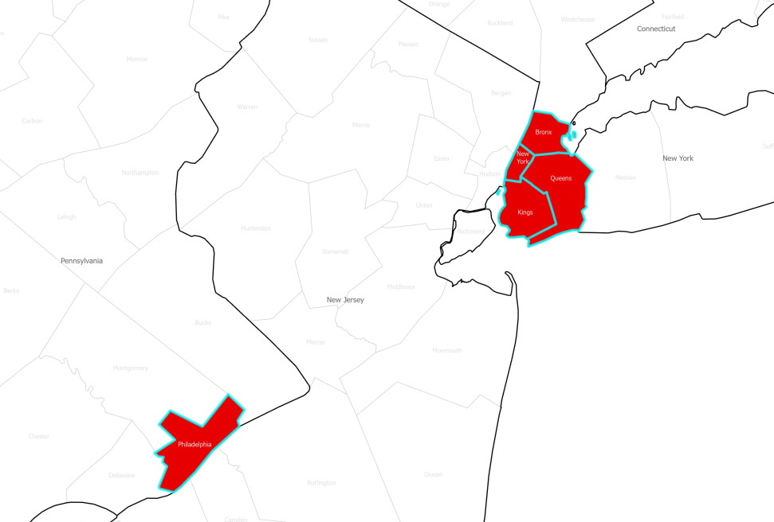

* 1. **Figure 2: US Counties with highest population density (US Census 2010)**

|  |  |  |  |  |  |  |  |
| --- | --- | --- | --- | --- | --- | --- | --- |
| |  |  |  |  | | --- | --- | --- | --- | | County and State |  |  |  | | Elderly Population Over Age 65 | Persons Per Square Mile | Number of Housing Units |
| New York County, New York | 48,765.0 | 214,153 | 847,090 |
| Kings County, New York | 26,416.7 | 287,633 | 1,000,293 |
| Bronx County, New York | 24,186.9 | 145,882 | 511,896 |
| Queens County, New York | 15,036.7 | 286,146 | 835,127 |
| Philadelphia County, Pennsylvania | 10,087.2 | 185,309 | 670,171 |

* 1. **Table 2: Top five counties with the highest population density, elderly population, and housing units.**